Peta Clarke
Slide 1

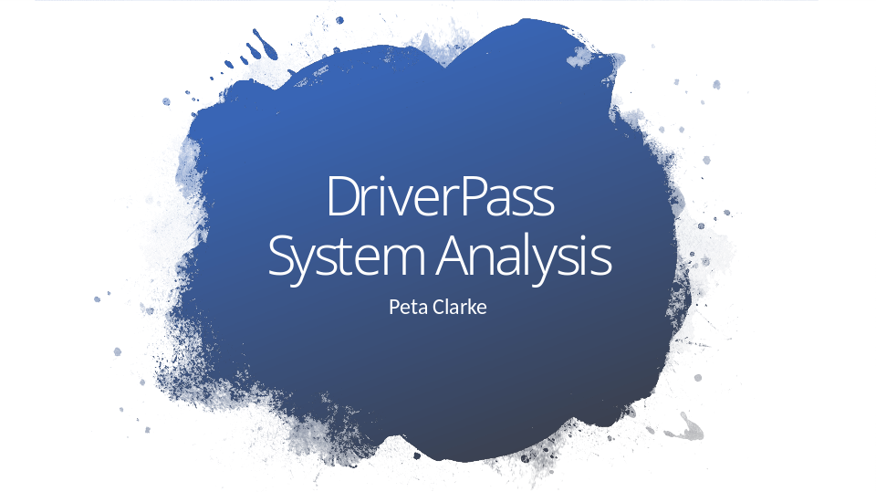

[No speaker notes required for this slide.]

Slide 2

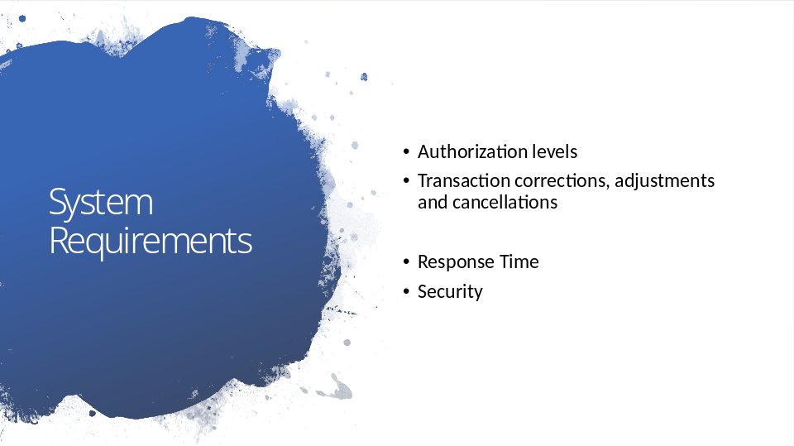

Functional requirements include Authorization levels and Transaction corrections. The program needs to authorize the various users and the customers need to be able to cancel or adjust their orders.
Nonfunctional requirements is the response time and security. The server should respond within 5ms and if any user enters invalid credentials more than 2 times, they will be prompted to reset their password.

Slide 3

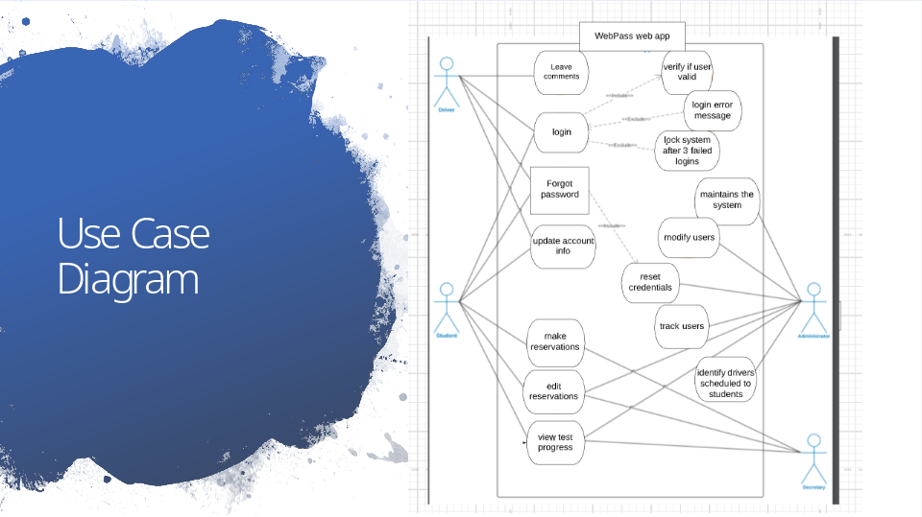

The different users in this system are the Student, Driver, Secretary and Administrators. These users have different and sometimes overlapping privileges.
The student will be able to book appointments and update their accounts and passwords. The driver will be able to update their account and leave comments. The admins will be able to update the system, track the users and activities. And the secretary will be able to schedule appointments.

Slide 4

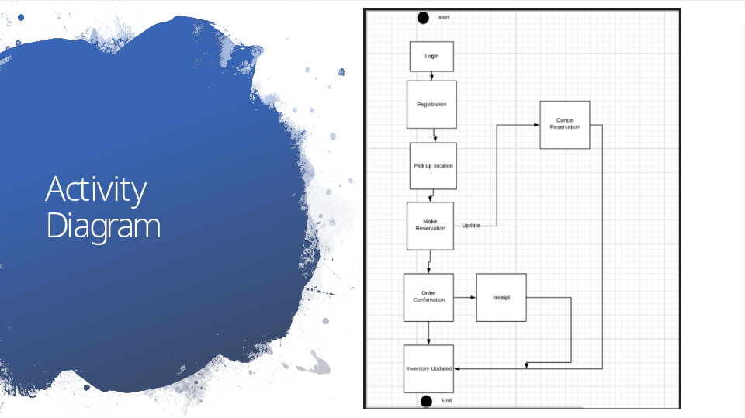

This diagram is breaking down the flow of the user’s appointment booking process. The user will first be registered or signed in. They will then choose their pickup location to make a reservation. Once the reservation is made, it can be canceled or changed. The user is then brought to an order confirmation screen and an email is sent out as a receipt. Finally, the inventory is updated.

Slide 5

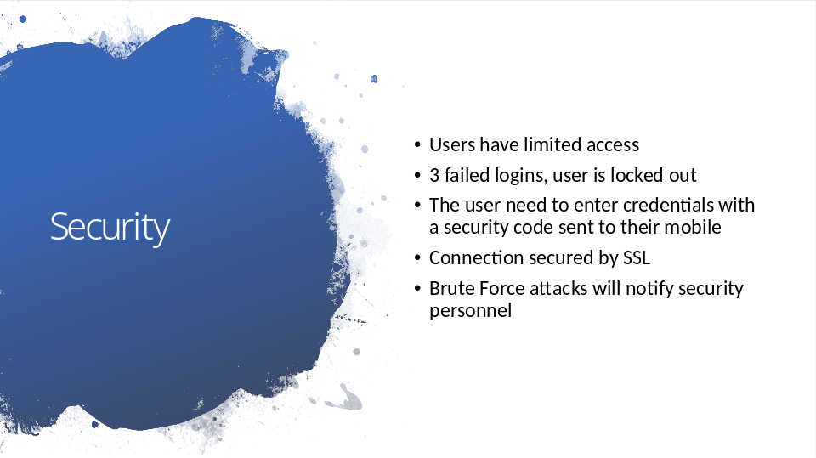

The system will maintain all system and user information securely and only give as little access to the different users as possible. If any user logs in unsuccessfully more than 3 times in a row, the system will lock them out until a password reset is done. The user will need to enter email and password along with a security code sent to their mobile. SSL provides an extra layer of security through features such as encryption (hiding sensitive information).

Slide 6

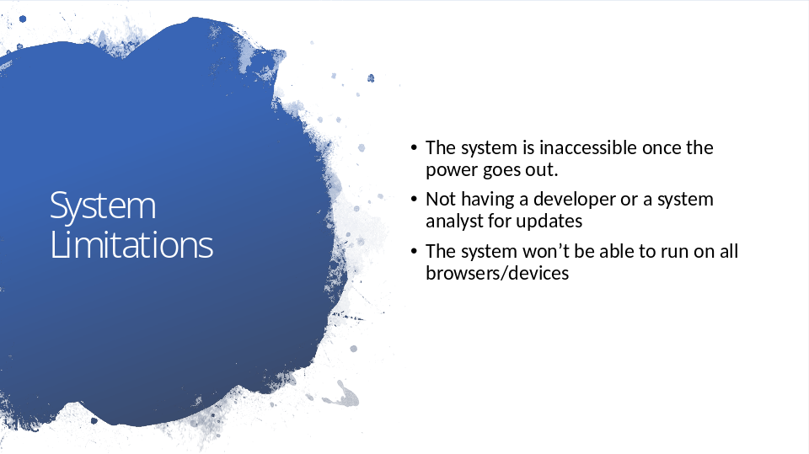

The system will only run on select up to date browsers to ensure security. The system will also not be available if there is power loss. This is done to ensure there is only one copy of said data. It is also essential to have a developer or systems analyst to handle future updates or the system will stay as is and will not grow with the changing times.

